The Chief Engineer
R&B Department,
Kashmir.

No: KGP/Estt/2026-27/923-924 Dated:19-08-2026
Subject: Request for utilisation of savings accrued from sanctioned/allotted works towards pending leftover works of Kashmir Government Polytechnic College, Srinagar.
Respected Sir,
With reference to the above-captioned subject, the status of the ongoing works in this institution are given below:
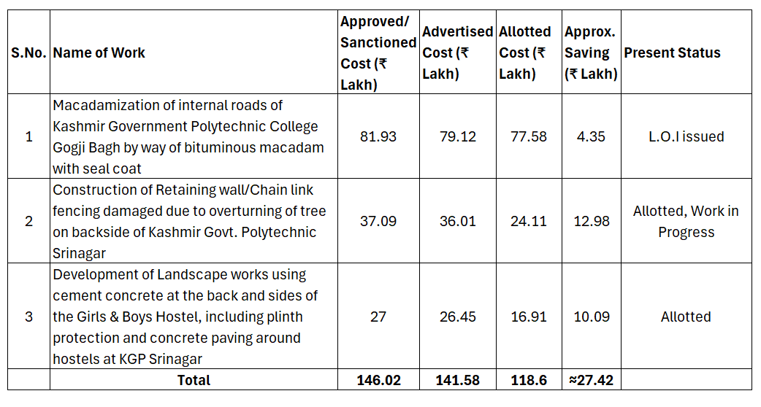It is submitted that a saving of approximately ₹27.42 Lakh has accrued on account of the difference between the approved/sanctioned cost and the allotted cost of the above three works.
In view of the above, it is most respectfully requested that the savings so accrued may kindly be permitted to be utilised for the pending leftover works of this institution to ensure optimal utilisation of the available funds for the infrastructural development of the College.
An early favourable consideration of this request is earnestly solicited.
Yours Faithfully

Principal
Kashmir Government Polytechnic College
Srinagar
Copy to:
1.Executive Engineer, R&B, Srinagar for information.
2. Office record.

